Korean Culture and Language Learning Center,
Faculty of Croatian Studies, University of Zagreb in cooperation
with Chung-Ang University of Korea

Method of Class

ONLINE (Zoom meeting)
※ Depending on the development of the COVID-19 pandemic situation, all class could be arranged online or changed to offline.

Class fee
? Kn
https://www.hrstud.unizg.hr/en/about_us

Location
Dvorana Sobaek(Borongajska cesta 83J) at Borongaj kampus
https://goo.gl/maps/q8ignNsKrPWX793b7
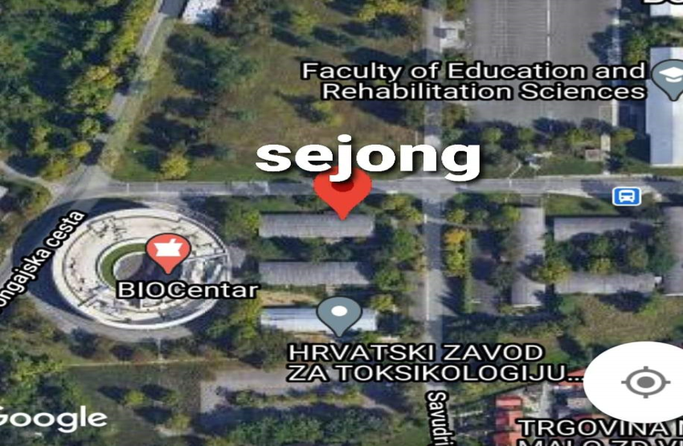
Instagram @sejongzagreb

Contact (English)
korejskijezik@hrstud.hr

Class Time
Group | Level | Date | Time | Classroom | Limit
1 | Elementary (Level 1) | Sat, Sun | 10:30~12:00 | Dvorana Sobaek | 16
2 | Elementary (Level 1) | Tue, Thurs | 17:30~19:00 | Dvorana Sobaek | 16
3 | Elementary (Level 2) | Sat, Sun | 13:00~14:30 | Dvorana Sobaek | 16
4 | Elementary (Level 2) | Tue, Thurs | 19:10~20:40 | Dvorana Sobaek | 16

Tue, Thurs 2, March ~ 17, June
Sat, Sun 6, March ~ 20, June
1.5 hours a day
3 hours a week
48 hours over 16weeks (Last week is Exam)

Instruction
Compulsory instruction - Students have 1.5 hours of compulsory language instruction each day, 2 days a week – Language instruction consists of specific grammar classes and proofreading classes in which one learns and practices grammar, expands their vocabulary, develops communication skills; and classes that are focused on specific language skills: reading, writing, listening and speaking. And include 2 hours of Korean culture education.

Additional instruction – Culture Class – Doesn’t check attendance. Attending is up to student.

Material
Buy textbook online or use E-book link with your device, or Print.

Level 1
Sejong Korean1
https://www.sejonghakdang.org/e-book/ecatalog5.jsp?Dir=373&catimage=&callmode=admin
Sejong Korean conversation1
https://www.sejonghakdang.org/e-book/ecatalog5.jsp?Dir=316&catimage=&callmode=admin

Level 2
Sejong Korean2
https://www.sejonghakdang.org/e-book/ecatalog5.jsp?Dir=382&catimage=&callmode=admin
Sejong Korean conversation2
https://www.sejonghakdang.org/e-book/ecatalog5.jsp?Dir=317&catimage=&callmode=admin

Print : Library google map
https://goo.gl/maps/QgoJtQJZsB7ZXJLp6

Mobile learning app:
Sejong Korean
Vocabulary: https://play.google.com/store/apps/details?id=schoolview.dcn.com.kingsejong
Grammar: https://play.google.com/store/apps/details?id=air.org.kingsejong.grammarbasic
Conversation: https://play.google.com/store/apps/details?id=com.sejong.koreanconversation

Youtube lecture
https://www.youtube.com/playlist?list=PL6D-YTosvGYq4BSGSUZom6etXcXcAu2Ym

https://www.youtube.com/playlist?list=PLInPGbDZkjSRJ2GN7Ba481NdJGifY_lvC

Sejong Google Drive
https://drive.google.com/drive/u/0/folders/127uPE2X2VBRi9Lg2szjHVcZEYkTi-ooN

Completion criteria
Attendance rate 70% (70/100), Level test 60 score (60/100)
22/32 times attendance

Lesson Plan
Language Class Plan Level 1A
Textbook |  | Sejong Korean 1, Sejong Korean conversation 1
Level |  | Elementary (Level 1A)
Materials |  | Textbook, Pictures, Audio, Video
week | unit | contents | culture | time
1 | pre-1 | Korea introduction/Korean alphabet - Hangeul | King Sejong history | 3h
2 | pre-2 | Hangeul Consonants, Vowels, and syllables1 |  | 3h
3 | pre-2 | Hangeul Consonants, Vowels, and syllables2  Final Consonants and syllables |  | 3h
4 | pre-3 | Classroom Expressions ,Greetings, Self-introductions  Grammar: 이에요/예요, 은/는  Vocabulary: Nationality, Occupations | Greetings in Korea | 3h
5 | 1 | Daily Activities  Grammar: -아요/어요, -에 가다  Vocabulary: Activities, Places |  | 3h
6 | 2 | Locations and positions  Describing Locations and positions of objects  Grammar: 이/가, -에 있다/없다  Vocabulary: Objects, Locations/Positions |  | 3h
7 | 3 | Shopping1  Reading numbers, Asking about price or quantity  Grammar: 을/를, -(으)세요  Vocabulary: Shopping items, Sino-Korean Numbers |  | 3h
8 | 4 | Shopping2  Describing Quantities, Buying Goods  Grammar: ㅂ니다/습니다, 니까/습니까, 하고  Vocabulary: Native Korean numbers, Unit Nouns | Korean Currency | 3h
9 | 5 | Yesterday’s Activities  Taking about what you did in the past  Grammar: -았/었-, 에서  Vocabulary: Activities, Places |  | 3h
10 | 6 | Weather  Describing Seasons and Weather  Grammar: 그리고, 안  Vocabulary: Seasons, Weather | The Four Seasons in Korea | 3h
11 | 7 | Times and Dates  Dates and days of the week, Talking about time  Grammar: 에, -시 –분  Vocabulary: Dates and days of the week, Time expressions |  | 3h
12 | 8 | Making an Appointment  Making a suggestion, Making an appointment  Grammar: -까요, -아요/어요  Time expressions, Contents of an appointment |  | 3h
13 | 9 | Weekend activities  Talking about weekend activities, Describing my plans  Grammar: 그래서, -을 거예요  Vocabulary: Places, Weekend activities | Weekend Activities in Korea | 3h
14 | 10 | Learning Korean  Talking about learning Korean  Review1 |  | 3h
15 | 11 | Plans  Describing my plans  Review2 |  | 3h
16 | 12 | Exam Orientation, Level Test |  | 3h

Language Class Plan Level 1B
Textbook |  | Sejong Korean 2, Sejong Korean conversation 2
Level |  | Elementary (Level 1B)
Materials |  | Textbook, Pictures, Audio, Video
week | unit | contents | culture | time
1 | pre-1 | 안부 |  | 3h
2 | pre-2 | 취미 활동 |  | 3h
3 | pre-2 | 음식 |  | 3h
4 | pre-3 | 교통 | Korean transportation | 3h
5 | 1 | 길 찾기 | Seoul street | 3h
6 | 2 | 전화 |  | 3h
7 | 3 | 외모 |  | 3h
8 | 4 | 가족 | Korean Family tradition | 3h
9 | 5 | 여행 | Korea Travelogue | 3h
10 | 6 | 건강 |  | 3h
11 | 7 | 모임 |  | 3h
12 | 8 | 고향 |  | 3h
13 | 9 | 기분과 감정 |  | 3h
14 | 10 | 미래 |  | 3h
15 | 11 | Exam practice, Speaking & Writing feedback |  | 3h
16 | 12 | Exam Orientation, Level Test |  | 3h

Culture Class(Additional class; Date; to be decided, upon COVID-19 situation)

- Korean Calligraphy, Korean painting art 16:00 Sat
- Korean sports Taekwondo 16:00 Sat
- Buddhist Meditation 16:00 Sat
- Korean Cooking 16:00 Sat

